6/15/2026
Sushrith Reddy Anyam

CI/CD PIPELINE FOR .NET WEB APPLICATION USING AZURE DEVOPS

Contents
1. INTRODUCTION 3
2. PROJECT OBJECTIVE 3
3. TECHNOLOGIES USED 4
4. SYSTEM ARCHITECTURE 5
5. AZURE RESOURCES USED 6
6. CI/CD PIPELINE OVERVIEW 6
7. CONTINUOUS INTEGRATION (CI) 7
8. CONTINUOUS DEPLOYMENT (CD) 7
9. ENVIRONMENT STRATEGY 7
10. TESTING STRATEGY 7
11. MONITORING & LOGGING 8
12. SECURITY IMPLEMENTATION 8
13. DEPLOYMENT WORKFLOW 8
14. SCREENSHOTS 9
15. FINAL OUTCOME 19
16. KEY LEARNINGS 19
17. CONCLUSION 20

1. INTRODUCTION
This project demonstrates the implementation of a complete CI/CD pipeline for a .NET web application using Azure DevOps and Azure App Service. The pipeline automates build, testing, and deployment across multiple environments including Dev, Staging, and Production.

2. PROJECT OBJECTIVE
The objectives of this project are:
- Automate build and deployment process
- Implement CI/CD pipeline using Azure DevOps
- Deploy application to Azure cloud
- Ensure code quality using automated testing
- Enable monitoring using Azure Application Insights

3. TECHNOLOGIES USED
- ASP.NET Core (.NET 8)
- Azure DevOps (YAML Pipelines)
- Azure App Service
- Azure Repos (Git)
- xUnit Testing Framework
- Azure Application Insights
- Git Version Control

4. SYSTEM ARCHITECTURE
Architecture Flow
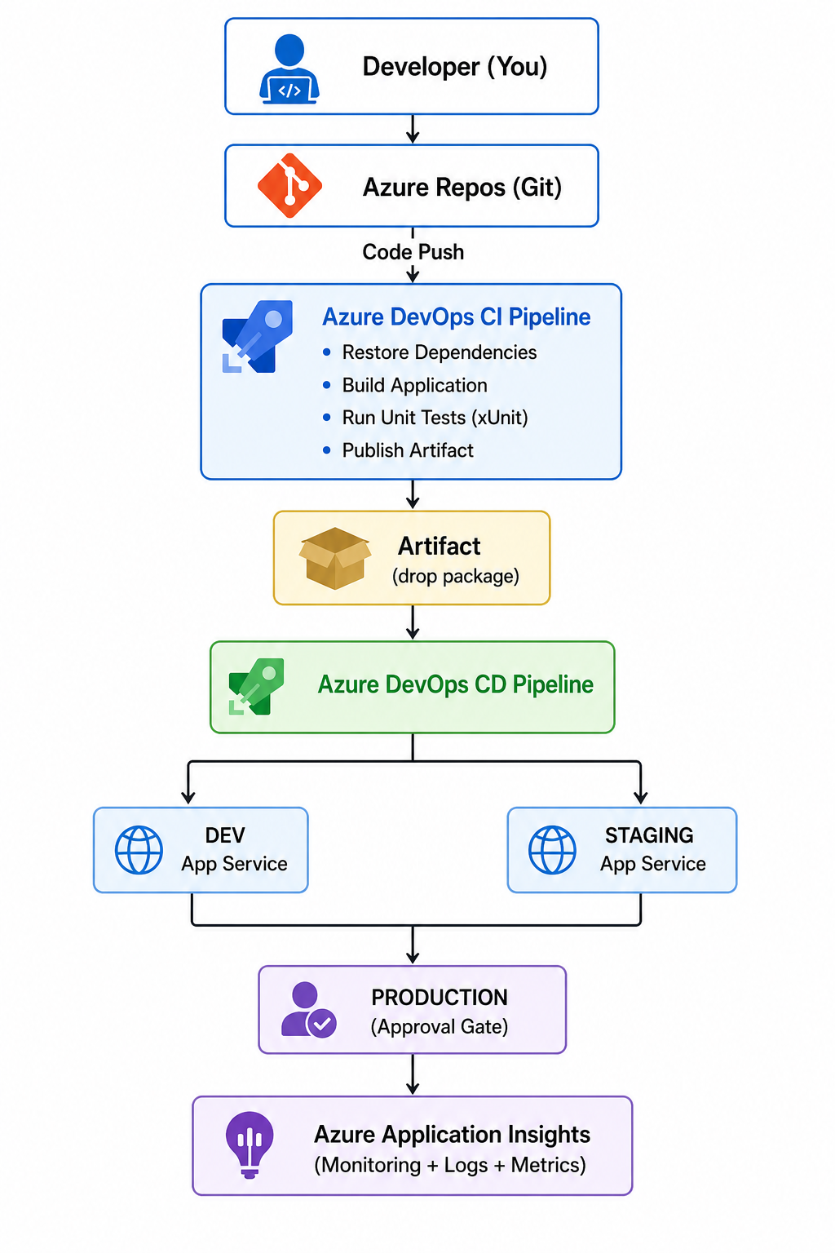

5. AZURE RESOURCES USED
- Azure Resource Group
- Azure App Service (Dev, Staging, Production)
- Azure App Service Plan
- Azure DevOps Project
- Azure Application Insights
- Azure Service Connection

6. CI/CD PIPELINE OVERVIEW
The pipeline is divided into two stages:
CI (Continuous Integration)
- Restore dependencies
- Build application
- Run unit tests (xUnit)
- Publish artifacts
CD (Continuous Deployment)
- Deploy to Dev
- Deploy to Staging
- Production deployment with approval
- Deploy to Production

7. CONTINUOUS INTEGRATION (CI)
CI ensures every code commit is validated automatically.
Steps:
- Code checkout from Azure Repos
- Restore NuGet packages
- Build solution
- Run unit tests
- Generate artifacts

8. CONTINUOUS DEPLOYMENT (CD)
CD pipeline automates deployment across environments:
Dev → Staging → Production (Approval Required)

9. ENVIRONMENT STRATEGY
Environment | Purpose | Approval
Dev | Development testing | No
Staging | Pre-production testing | No
Production | Live environment | Yes

10. TESTING STRATEGY
Unit testing is implemented using xUnit framework.
Benefits:
- Early bug detection
- Code validation
- Improved stability

11. MONITORING & LOGGING
Azure Application Insights provides:
- Live request tracking
- Performance monitoring
- Failure detection
- Dependency tracking

12. SECURITY IMPLEMENTATION
- Azure Service Connection for secure deployment
- Role-based access control (RBAC)
- Approval gate for production
- Environment-based protection

13. DEPLOYMENT WORKFLOW
Developer commits code
→ Azure Repos
→ CI Pipeline triggered
→ Build + Test + Publish
→ CD Pipeline triggered
→ Dev Deployment
→ Staging Deployment
→ Production Approval
→ Production Deployment
→ Monitoring (App Insights)

14. SCREENSHOTS

14.1 Azure Resource Group
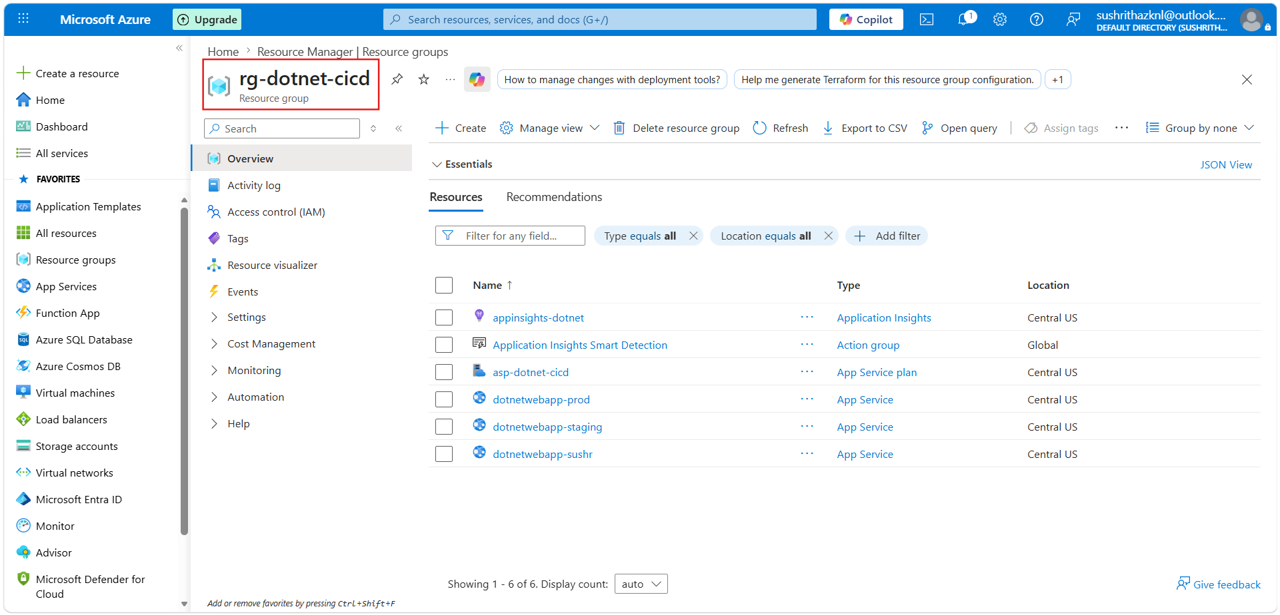
Figure 1: This shows all Azure resources grouped under a single resource group.

14.2 CI Pipeline (Build + Test)
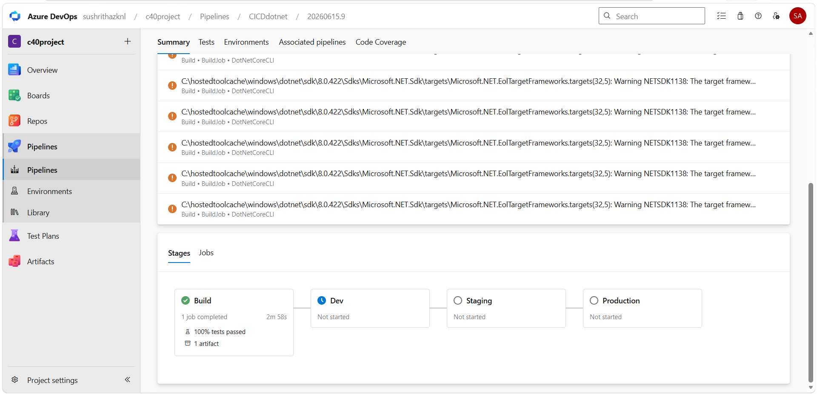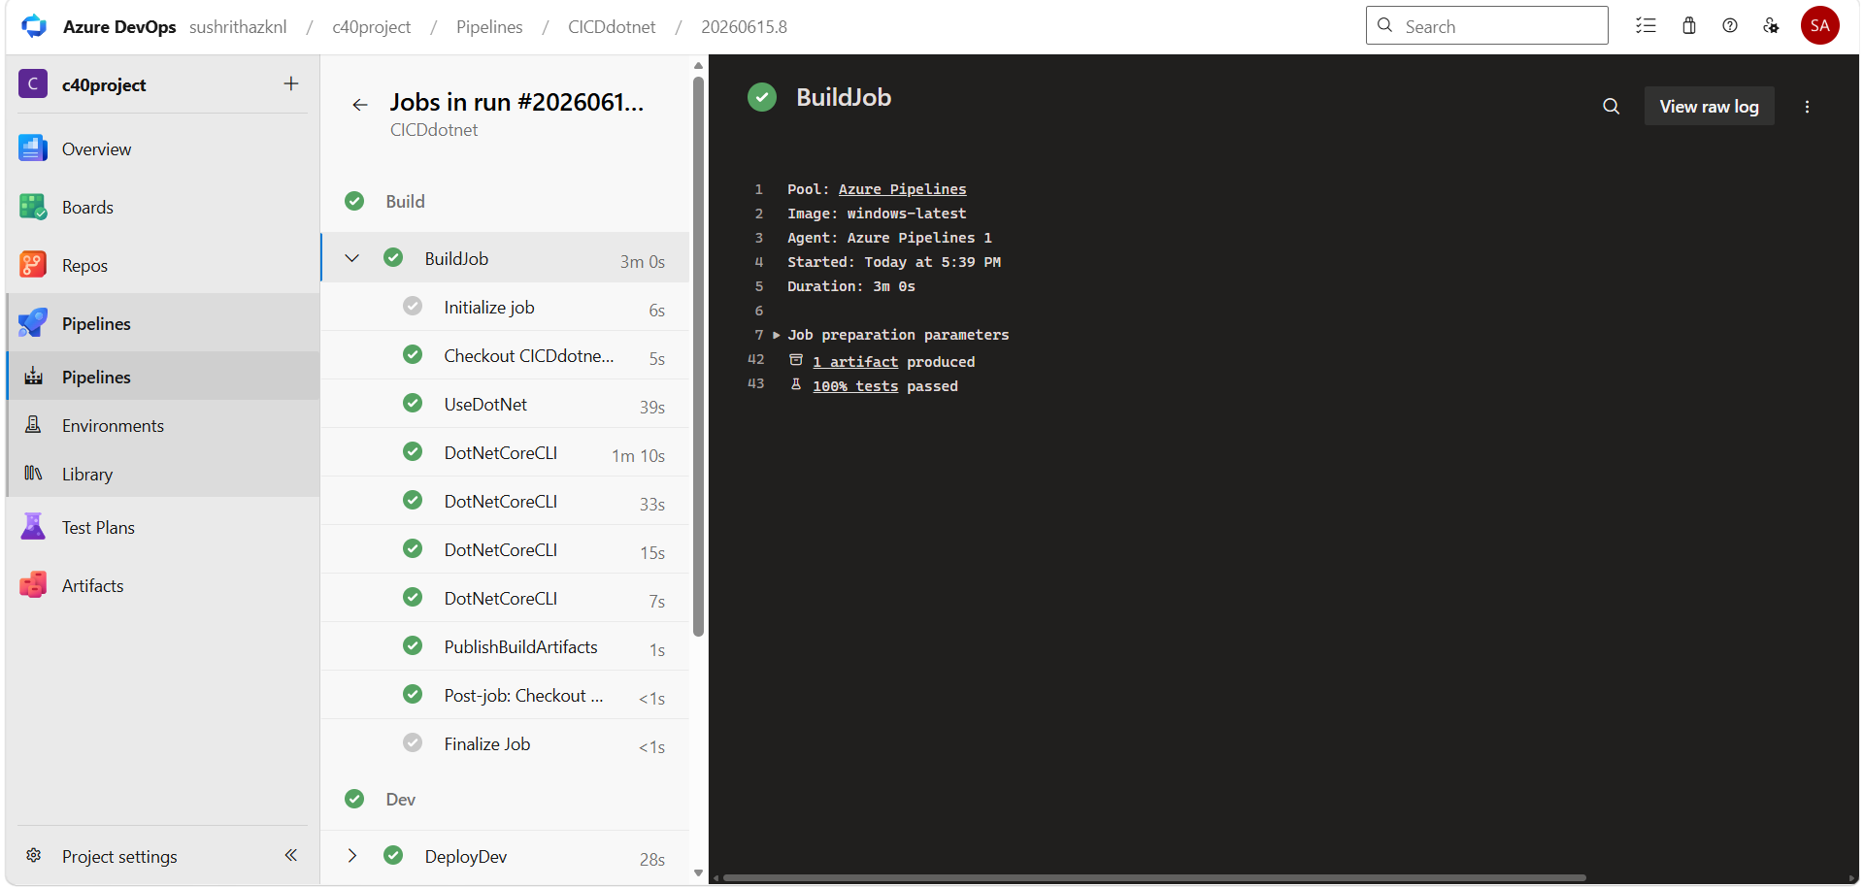
CI pipeline builds the application and runs xUnit test cases successfully.

14.3 CD Pipeline Stages
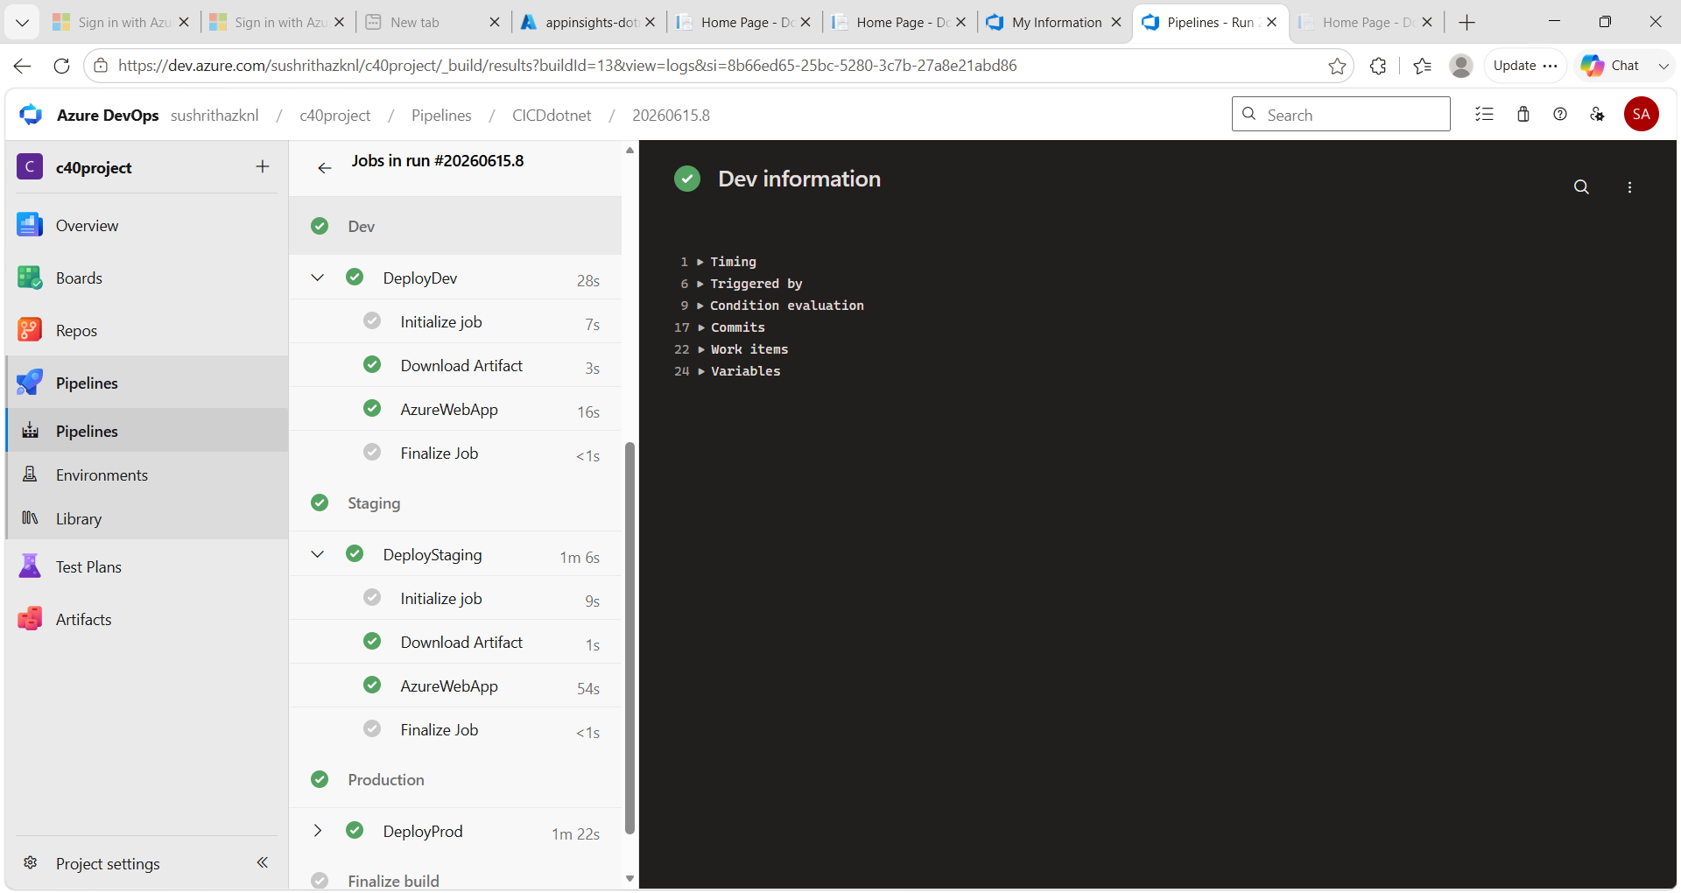
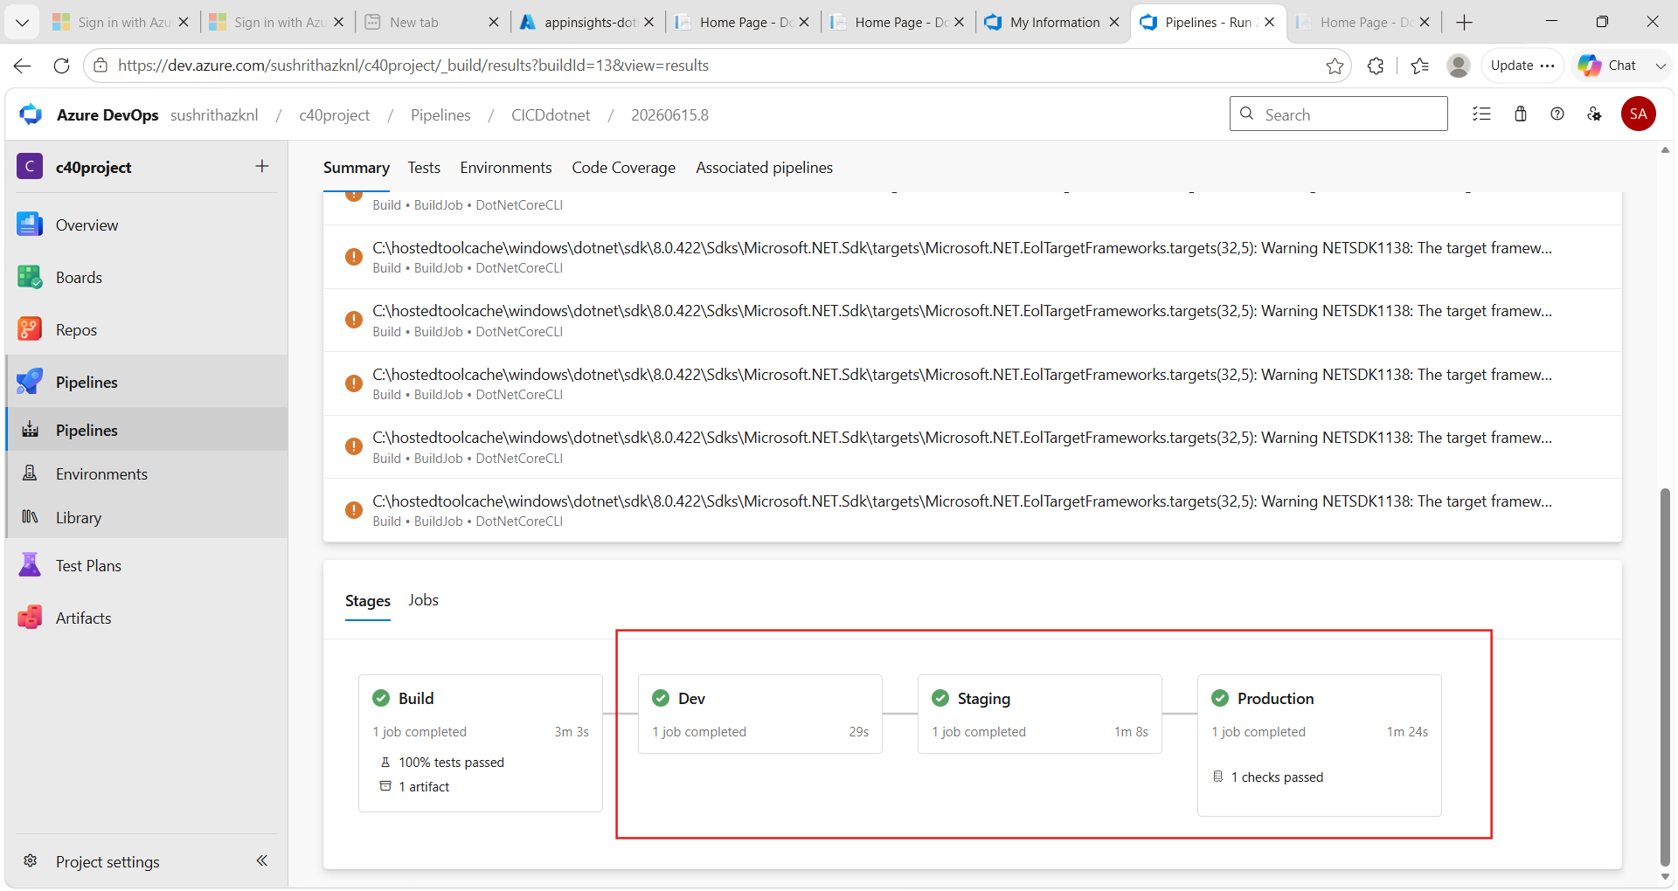
Shows deployment across Dev, Staging, and Production environments.

14.4 Production Approval Gate
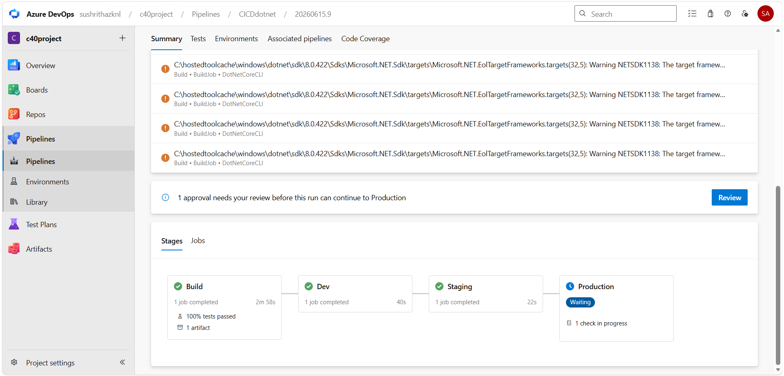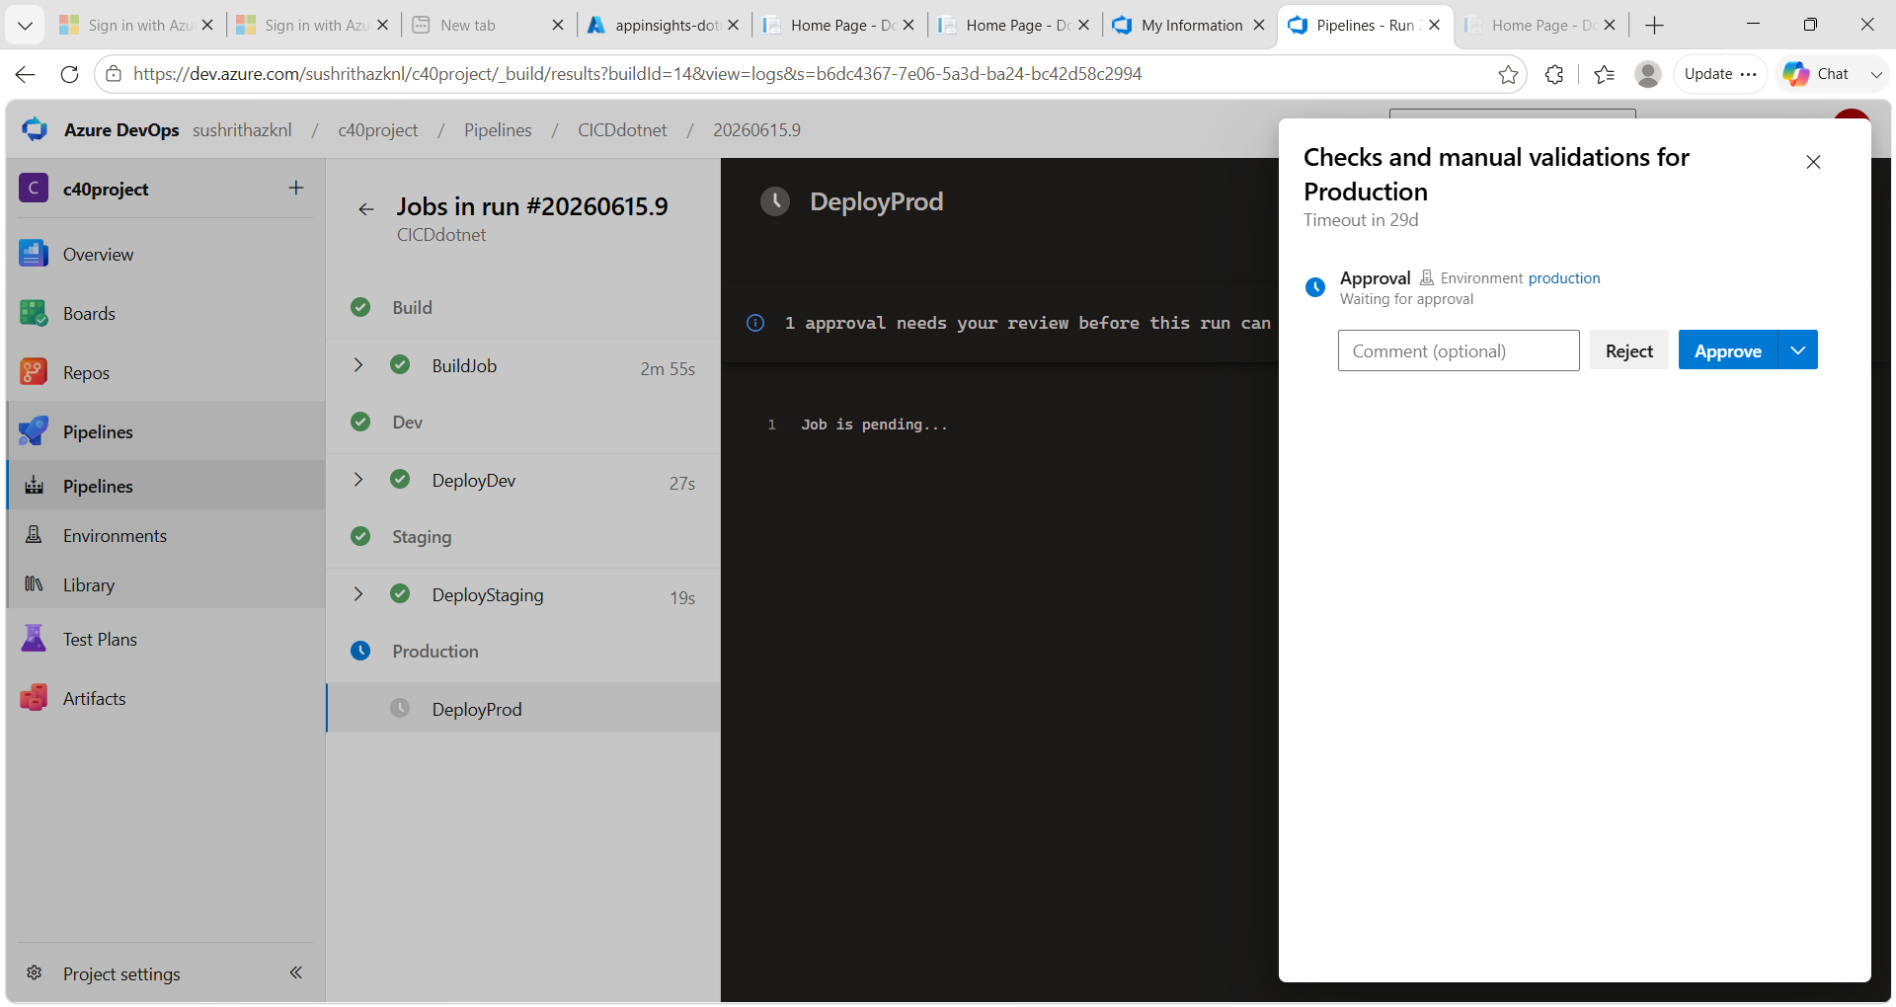
Manual approval is required before production deployment.

14.5 Artifact Generated
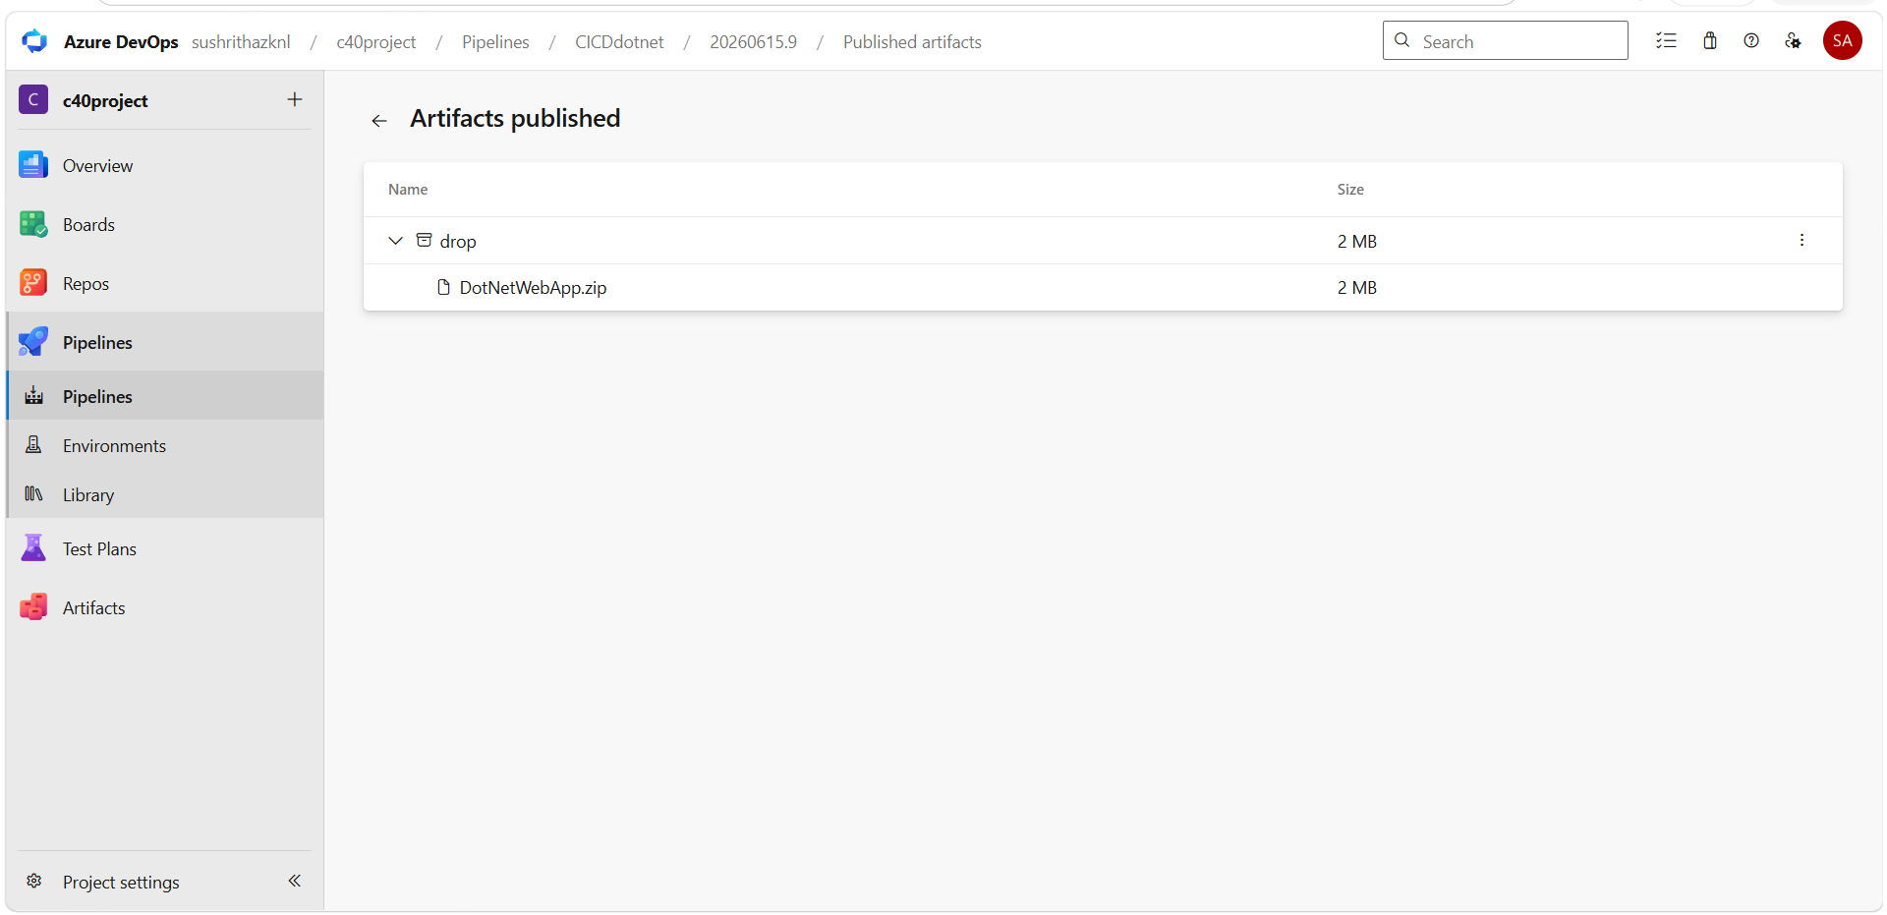
This artifact contains the compiled and packaged application ready for deployment to Azure App Service.

14.6 Dev App Service
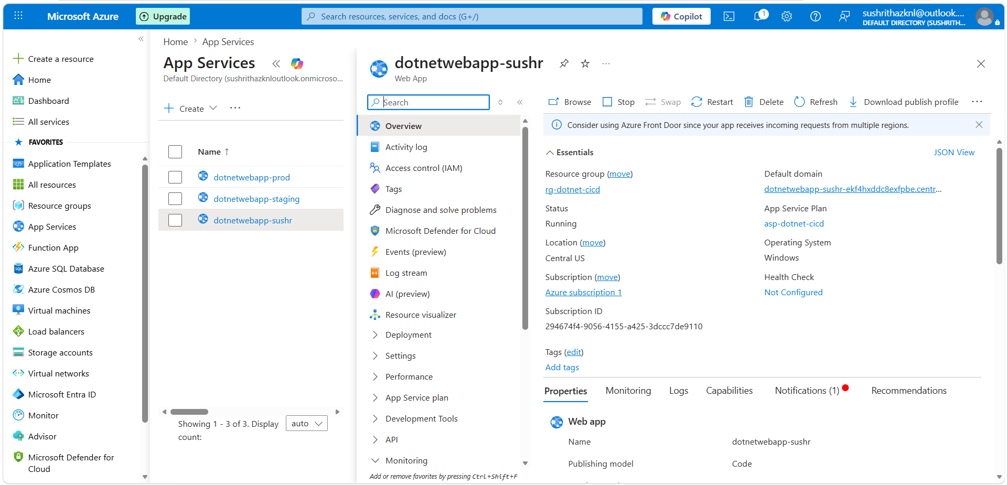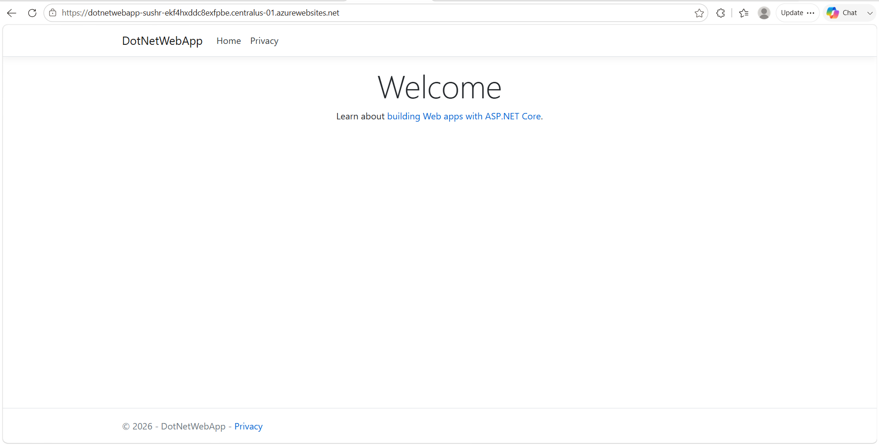
Development environment deployed on Azure App Service.

14.7 Staging App Service
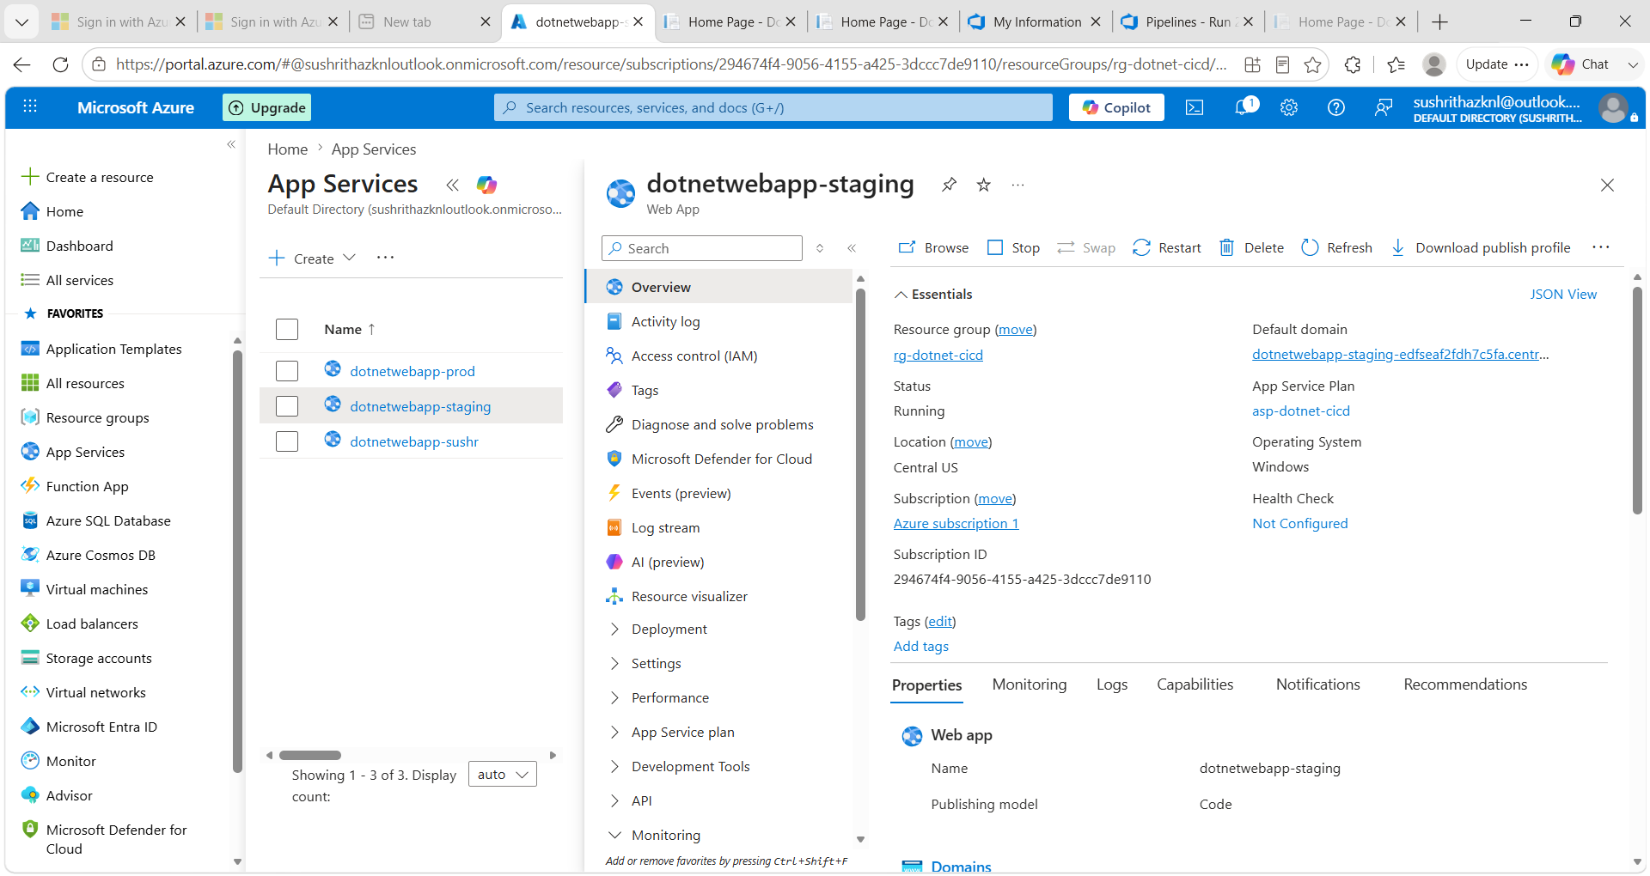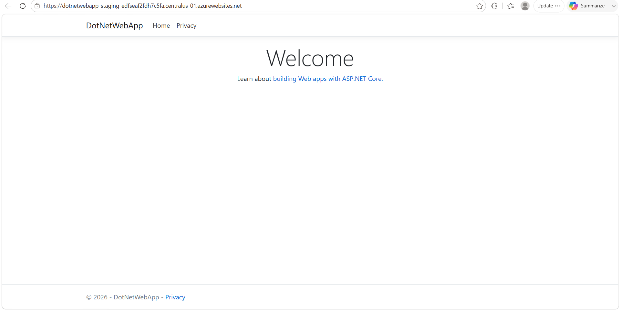
Pre-production testing environment.

14.8 Production App Service
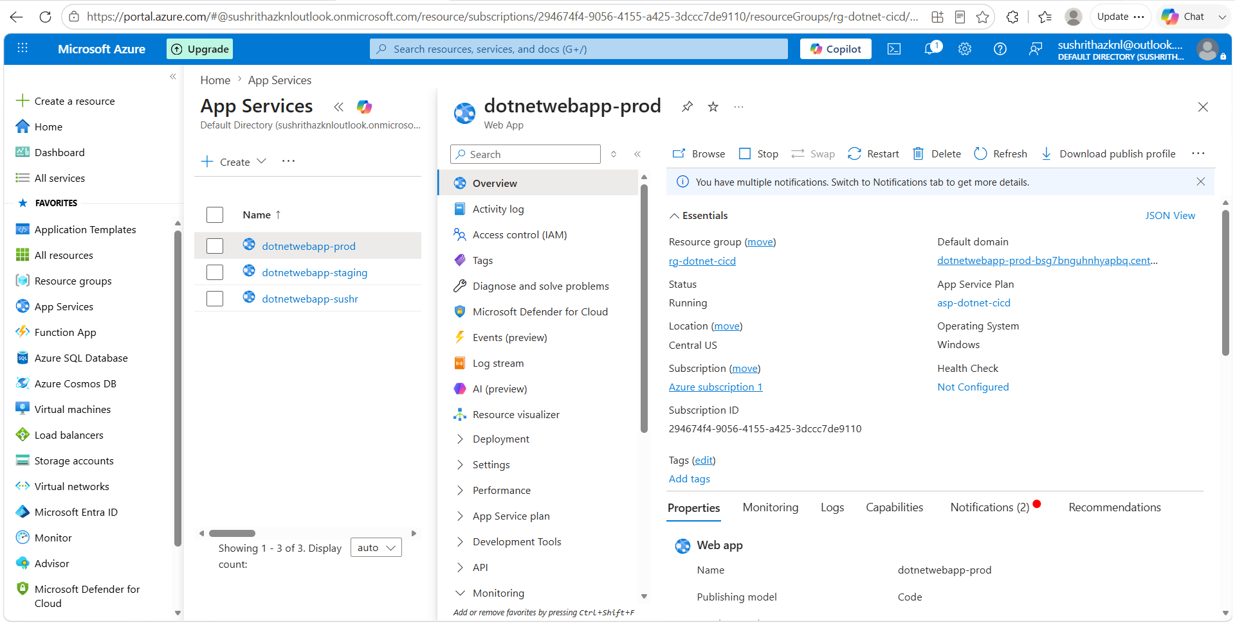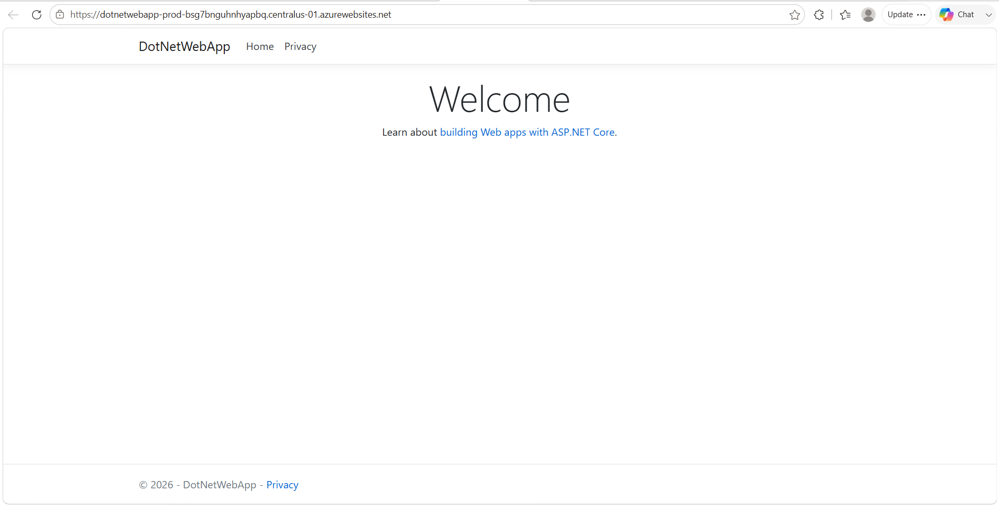
Live production environment for end users.

14.9 Live Application
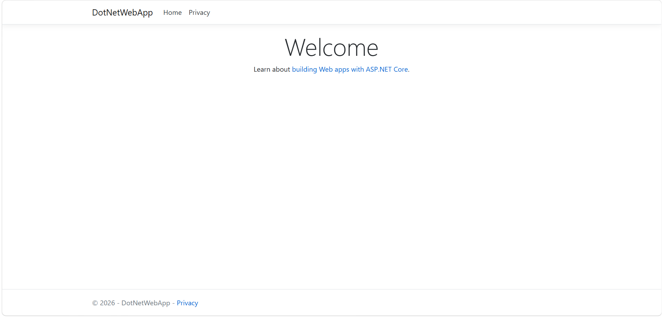
Application successfully deployed and accessible via internet.

14.10 Application Insights Dashboard
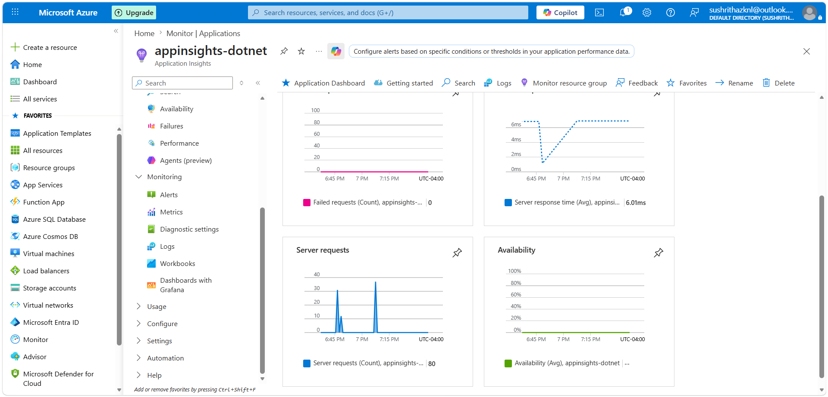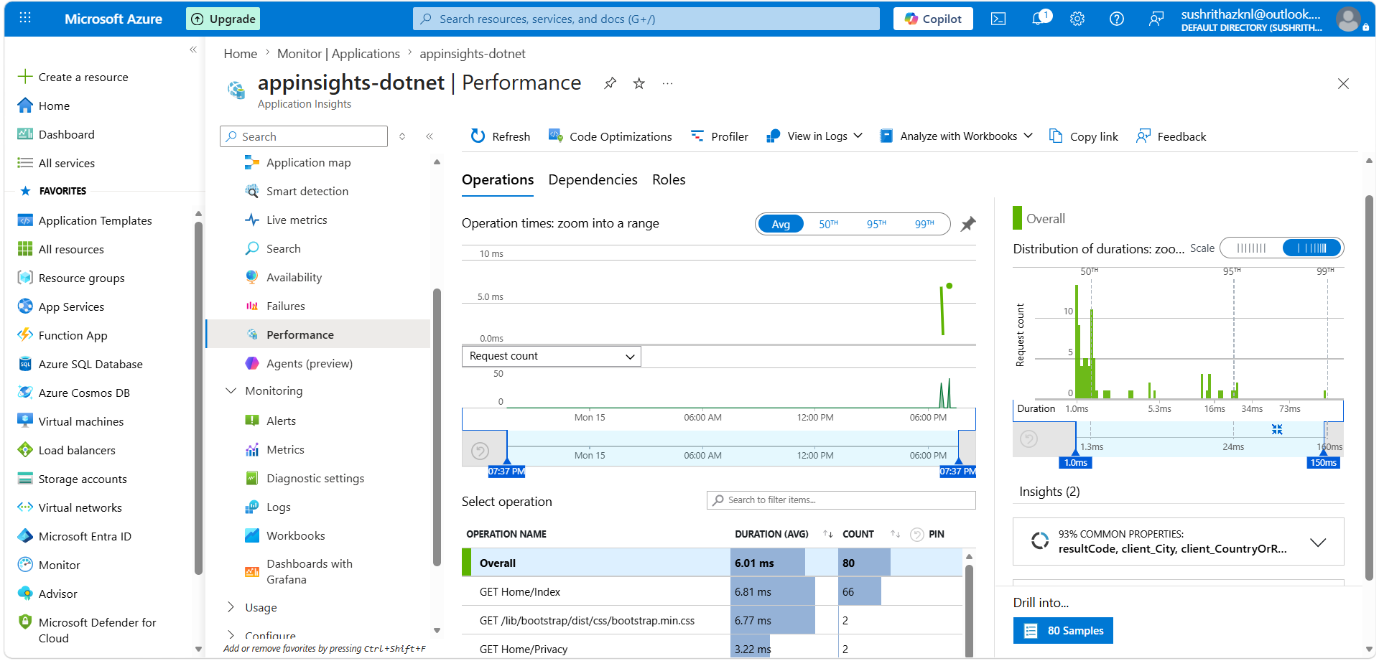
Monitoring dashboard showing performance metrics and logs.

14.11 Azure DevOps Environments
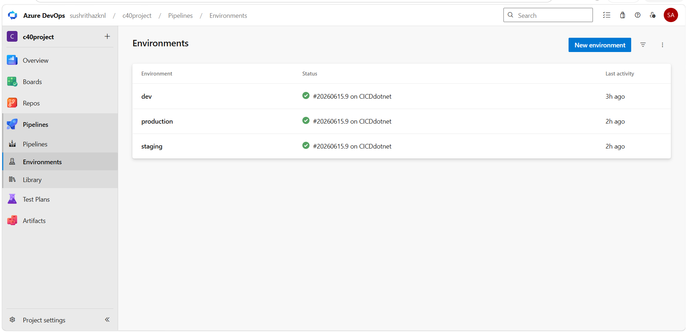
Shows configured Dev, Staging, and Production environments.

15. FINAL OUTCOME
- Fully automated CI/CD pipeline implemented
- Multi-environment deployment achieved
- Cloud-hosted application on Azure
- Production approval workflow enabled
- Monitoring enabled using Application Insights

16. KEY LEARNINGS
- Azure DevOps CI/CD pipeline creation
- Cloud deployment using Azure App Service
- YAML pipeline automation
- Unit testing using xUnit
- Monitoring using Azure tools

17. CONCLUSION
This project demonstrates a real-world DevOps CI/CD implementation using Azure DevOps and Azure App Service. It follows industry best practices including automation, testing, approvals, and monitoring.

